**GAYATRI VIDYA PARISHAD COLLEGE OF ENGINEERING FOR WOMEN**

**(Approved by AICTE NEW Delhi, Affiliated to JNTUK Kakinada)**

[Accredited by National Board of Accreditation (NBA) for CSE, ECE, IT – Valid from 2019-20 to 2021-22]

Kommadhi, Madhurawada, Visakhapatnam -530048

**Department of Computer Science and Engineering**

**DOCUMENT UTILITY**

Submitted by

Batchu Srihasa Jyothsna (18JG1A0509)

Ganagalla Priya Varshini (18JG1A0526)

Karri Sadaa Navya Srija (18JG1A0543)

Kondala Sravani(18JG1A0551)

Under the Guidance of

Ms. K. Rohini

Assistant Professor

(Signature of Guide) (Signature of Co-ordinator)

**ABSTRACT**

Now a days Everything is going online and Several methods are developed to generate certificates in online mode to come out of difficulties faced in manual process and minimize the Processing time.

Our project “Document Utility” mainly focuses on generating study certificates in online mode and making them available to the students through their mails. Students are eligible to apply for the certificate only if they satisfy the requirements criteria.

So, we built a platform to generate study certificates in web which helps the students to get their certificates when they need them in less time in an efficient way.

**INTRODUCTION**

Django is a high-level Python web framework that enables rapid development of secure and maintainable websites. **Django** takes care of much of the hassle of web development, so you can focus on writing your app without needing to reinvent the wheel. We have used Django framework to develop a platform where students can apply for Study Certificates in a web based mode.

When the Student need to apply for certificate he/she should meet the eligibility Criteria. Students having attendance percentage greater than 80 and backlogs less than 3 are eligible and redirected to the registration page. Eligibility Details entered by the student will be stored in database table named “Eligible”. In registration page student fills the details and once he click on register button he/she will be asked whether they want to modify any details. After filling the details they will be stored in database table named “Details”.

We have used PostgreSQL database which is an open-source relational database management system(RDBMS) that is used to store various complicated data. **PgAdmin** is graphical user interface administration tool for **PostgreSQL**. After the details are stored successfully in database admin will retrieve the certificate requests submitted today at the end of the day and convert them into pdf format and download the file in local system.

Finally, admin will send the pdf containing all requested certificates i.e., one certificate per page to the mails of students registered today. Students can retrieve their certificates by extracting the page consisting their certificate.

**REQUIREMENTS**

**Hardware Requirements:**

Processor🡪 Intel Core i3 and i5

RAM🡪 4GB and 8GB

System Type🡪 64bit Operating System.

**Software Requirements:**

PostgreSQL 13.0.1

- PostgreSQL database is an open-source relational database management system(RDBMS) that is used to store various complicated data.

pgAdmin v4.0.6

* **PgAdmin** is graphical user interface administration tool

for **PostgreSQL**.

vs code

* **Visual Studio Code** is a streamlined **code editor** with support for development operations like debugging, task running, and version control.

Python 3.8 and 3.9

* Python is a popular programming language used to create web applications and can handle big data.

Django 3.1.1

* Django is a high-level Python web framework that enables rapid development of secure and maintainable websites. **Django** takes care of much of the hassle of web development, so you can focus on writing your app without needing to reinvent the wheel.

**DESIGN**

**(DATABASE TABLES)**

**Table 1: Eligibity Details**

|  |  |  |
| --- | --- | --- |
| **id** | **attendance** | **backlog** |
|  |  |  |
|  |  |  |
|  |  |  |
|  |  |  |
|  |  |  |
|  |  |  |

This table stores the attendance percentage and number of backlogs in academics of a student who is applying for the study Certificate. If the attendance percentage is greater than eighty and maximum number of backlogs is less than 3 then student is eligible to apply for certificate otherwise not eligible.

**Table 2: Student Details**

|  |  |  |  |  |  |  |  |  |  |
| --- | --- | --- | --- | --- | --- | --- | --- | --- | --- |
| **Id** | **name** | **rollno** | **email** | **branch** | **year** | **parent** | **character** | **duration** | **date** |
|  |  |  |  |  |  |  |  |  |  |
|  |  |  |  |  |  |  |  |  |  |
|  |  |  |  |  |  |  |  |  |  |
|  |  |  |  |  |  |  |  |  |  |
|  |  |  |  |  |  |  |  |  |  |
|  |  |  |  |  |  |  |  |  |  |

This table stores all the details of a student such as name, roll-number, email, branch, year, parent name, duration. Date field takes the date on which the student is applying for certificate. These details are referred to print on the study Certificate.

**CODE**

**File name: settings.py**

INSTALLED_APPS = [

'django.contrib.admin',

'django.contrib.auth',

'django.contrib.contenttypes',

'django.contrib.sessions',

'django.contrib.messages',

'django.contrib.staticfiles',

'myapp',

]­­

**File name: urls.py**

from django.contrib import admin

from django.urls import path,include

from myapp import views

urlpatterns = [

path('admin/', admin.site.urls);

­­­­­­­ path('register/',views.register,name="register"),

path('display/',views.display,name="display"),

path('certi/',views.certi,name="certi"),

path('home/',views.home,name="home"),

path('mail/',views.mail,name="mail"),

path('update/',views.update,name="upd"),

path('validation/',views.validation,name="valid"),

path('continue/',views.cont,name="continue"),]

File name: models.py

from django.db import models

from django.conf import settings

# Create your models here.

class Student(models.Model):

branches=(

('ece','ECE'),

('cse','CSE'),

('it','IT'),

('eee','EEE')

)

year=(

('first','1st'),

('second','2nd'),

('third','3rd'),

('fourth','4th')

)

Dur=(

('first','2020-2024'),

('second','2019-2023'),

('third','2018-2022'),

('fourth','2017-2021')

)

Name=models.CharField(max_length=25)

ParentName=models.CharField(max_length=25)

Duration=models.CharField(max_length=15,choices=Dur,default="2018-2019")

Year=models.CharField(max_length=10,choices=year)

Roll=models.CharField(max_length=15)

Department=models.CharField(max_length=10,choices=branches)

Character=models.CharField(max_length=15)

Email=models.EmailField(max_length=30,default="xyz@gmail.com")

Date=models.DateField(auto_now_add=True)

class Valid(models.Model):

Attendance=models.IntegerField(max_length=5)

Backlog=models.IntegerField(max_length=5)

**File name: views.py**

from django.shortcuts import render,redirect

from django.http import HttpResponse

from myapp.models import Student,Valid

from django.contrib import messages

from datetime import date

from documentutility import settings

from django.core.mail import EmailMessage

from django.core.mail import send_mail

def home(request):

return render(request,'myapp/navbar.html')

def validation(request):

if request.method=="POST":

obj=Valid()

obj.Attendance=request.POST.get('attendance')

obj.Backlog=request.POST.get('backlog')

obj.save()

if(obj.Attendance> '80' and obj.Backlog<= '2'):

return render(request,'myapp/demo.html',{})

else:

return HttpResponse("<center><h1>You are not eligible for certificate</h1></center>")

return render(request,'myapp/eligible.html')

def register(request):

if request.method=="POST":

n=request.POST['name']

p=request.POST['pname']

r=request.POST['roll']

e=request.POST['email']

d=request.POST['department']

y=request.POST['year']

dur=request.POST['duration']

ch=request.POST['character']

sa=Student.objects.create(Name=n,ParentName=p,Duration=dur,Year=y,Roll=r,Department=d,Character=ch,Email=e)

sa.save()

messages.success(request,'Registration Successfull!!!')

return redirect('/display')

return render(request,'myapp/register.html')

def display(request):

data=Student.objects.last()

return render(request,'myapp/display.html',{'data':data})

def update(request):

dat=Student.objects.last()

if request.method=="POST":

n=request.POST['name']

p=request.POST['pname']

r=request.POST['roll']

e=request.POST['email']

d=request.POST['department']

y=request.POST['year']

dur=request.POST['duration']

ch=request.POST['character']

dat.Name=n

dat.ParentName=p

dat.Roll=r

dat.Department=d

dat.Year=y

dat.Duration=dur

dat.Character=ch

dat.save()

return HttpResponse("<center><h1>Details Updated Successfully</h1></center>")

return render(request,'myapp/update.html',{'info':dat})

def cont(request):

return HttpResponse("<h1>Details Saved Successfully!!!</h1>")

def certi(request):

d= Student.objects.filter(Date=date.today())

for obj in d:

print(obj)

today=date.today()

d1=today.strftime("%d/%m/%Y")

return render(request,'myapp/certi.html',{'d':d,'d1':d1})

def mail(request):

object= Student.objects.filter(Date=date.today())

l=[]

for i in object:

l.append(i.Email)

if request.method=='POST':

sub='Study Certificate'

msg='press CTRL+F to find your certificate and extract it from pdf '

sender=settings.EMAIL_HOST_USER

email=EmailMessage(sub,msg,sender,l)

email.content_subtype='html'

file=request.FILES.get('files')

email.attach(file.name,file.read(),file.content_type)

email.send()

return HttpResponse("<h1>Mail Sent Successfully!!</h1>")

return render(request,'myapp/mail.html')

**File name: home.html**

{% load static %}

<!DOCTYPE html>

<html lang="en">

<head>

  <title>Home Page</title>

  <style>

    img{

      width: 200px;

      height: 200px;

      }

      body{

      background-image: url('https://wallpaperaccess.com/full/1668999.jpg');

      }

      marquee{

          color:blue;

      }

  </style>

  <meta charset="utf-8">

  <meta name="viewport" content="width=device-width, initial-scale=1">

  <link rel="stylesheet" href="https://maxcdn.bootstrapcdn.com/bootstrap/4.5.2/css/bootstrap.min.css">

  <script src="https://ajax.googleapis.com/ajax/libs/jquery/3.5.1/jquery.min.js"></script>

  <script src="https://cdnjs.cloudflare.com/ajax/libs/popper.js/1.16.0/umd/popper.min.js"></script>

  <script src="https://maxcdn.bootstrapcdn.com/bootstrap/4.5.2/js/bootstrap.min.js"></script>

</head>

<body>

<nav class="navbar navbar-expand-sm bg-dark">

   <a class="navbar-brand" href="#" style="color:white">Document Utility</a>

  <ul class="navbar-nav ml-auto" style="margin-right: 50px;padding-top: 3px">

    <li class="nav-item">

      <a class="nav-link" href="{% url 'validation' %}" style="font-size: 20px; color: white">Register</a>

    </li>

     </ul>

 </nav>

<br>

<h2><marquee><b>WELCOME TO DOCUMENT UTILITY</b></marquee></h2>

<center><img src="{% static 'images/logo.jpg' %}"></center>

<center>

<div class="jumbotron col-md-6 color:midnightblue" style="color: black">

  <h3>Document Utility provides a platform where you can generate study certificates online.</h2>

</div>

</center>

</body>

**File name: eligible.html**

{% load static %}

<!DOCTYPE html>

<html lan="en">

<head>

<title>Validation</title>

<style>

     body{

        margin: 0;

        padding: 0;

        font-family: sans-serif;

        background: #34495e;

        background-image:url(https://wallpaperaccess.com/thumb/187161.jpg);

      background-size: cover;

      background-size: cover;

      }

      .box{

        width: 500px;

        padding: 40px;

        position: absolute;

        top: 50%;

        left: 50%;

        transform: translate(-50%,-50%);

        background: #191919;

        text-align: center;

      }

      .box h1{

        color: white;

        text-transform: uppercase;

        font-weight: 500;

      }

      .box input[type = "number"],.box input[type = "number"]{

        border:0;

        background: none;

        display: block;

        margin: 20px auto;

        text-align: center;

        border: 2px solid #3498db;

        padding: 14px 10px;

        padding-top: 20px;

        width: 200px;

        outline: none;

        color: white;

        border-radius: 24px;

        transition: 0.25s;

          font: -webkit-mini-control;

        border-bottom-width: thick;

      }

      .box input[type = "number"]:focus,.box input[type = "number"]:focus{

        width: 350px;

        padding-top: 20px;

        border-color: #2ecc71;

      }

      .box input[type = "submit"]{

        border:0;

        background: none;

        display: block;

        width: 40%;

        margin: 20px auto;

        text-align: center;

        border: 2px solid #2ecc71;

        padding: 14px 40px;

        outline: none;

        color: white;

        border-radius: 24px;

        transition: 0.25s;

        cursor: pointer;

}

      .box input[type = "submit"]:hover{

        background: #2ecc71;

      }

</style>

<meta charset="utf-8">

 <meta name="viewport" content="width=device-width, initial-scale=1">

 <link rel="stylesheet" href="https://maxcdn.bootstrapcdn.com/bootstrap/4.5.2/css/bootstrap.min.css">

 <script src="https://ajax.googleapis.com/ajax/libs/jquery/3.5.1/jquery.min.js"></script>

 <script src="https://cdnjs.cloudflare.com/ajax/libs/popper.js/1.16.0/umd/popper.min.js"></script>

 <script src="https://maxcdn.bootstrapcdn.com/bootstrap/4.5.2/js/bootstrap.min.js"></script>

</head>

<body>

<center>

<form class="box" action="{% url 'validation' %}" method="POST">

  {% csrf_token %}

  <h1>Eligibility</h1>

  <input type="number" name="attendance" placeholder="Enter Your Attendance" class="form-control">

  <input type="number" name="backlog" placeholder="Enter Number of backlogs" class="form-control">

  <input type="submit" class="btn btn-success text-center btn-block" value="Submit">

</form>

</center>

</body>

</html>

**File name: register.html**

<!DOCTYPE html>

    <html lan="en">

    <head>

      <style>

       body{

          background-image:url('https://wallpaperaccess.com/thumb/187161.jpg');

          background-repeat: no-repeat;

          background-size: cover;

          }

          .box{

            width: 1000px;

            height: 820px;

            padding: 80px;

            position: absolute;

            top: 50%;

            left: 50%;

            transform: translate(-50%,-50%);

            background: #191919;

            text-align: center;

          }

          .box input[type = "submit"]{

            border:0;

            background: none;

            display: block;

            width: 500px;

            margin: 20px auto;

            text-align: center;

            border: 2px solid #2ecc71;

            padding: 14px;

            outline: none;

            color: white;

            border-radius: 24px;

            transition: 0.25s;

            cursor: pointer;

          }

          .box input[type = "submit"]:hover{

            background: #2ecc71;

          }

          .box h1{

            color: white;

            text-transform: uppercase;

            font-weight: 500;

            margin-top: 10px;

          }

          .box input[type = "text"],.box input[type = "text"],.box input[type="email"]{

            border:0;

            background: none;

            display: block;

            margin: 20px auto;

            text-align: center;

            border: 2px solid #3498db;

            padding: 14px 10px;

            padding-top: 20px;

            width: 350px;

            outline: none;

            color: white;

            border-radius: 24px;

            transition: 0.25s;

              font: -webkit-mini-control;

            border-bottom-width: thick;

          }

          .box input[type = "number"]:focus,.box input[type = "number"],.box input[type="email"]:focus{

            width: 350px;

            padding-top: 20px;

            border-color: #2ecc71;

          }

          .box select{

            border:0;

            background: none;

            display: block;

            margin: 20px auto;

            text-align: center;

            border: 2px solid #3498db;

            padding: 14px 10px;

            padding-top: 20px;

            width: 350px;

            outline: none;

            color: white;

            border-radius: 24px;

            transition: 0.25s;

              font: -webkit-mini-control;

            border-bottom-width: thick;

            visibility:visible;

          }

          .box select:focus{

            width: 350px;

            padding-top: 20px;

            border-color: #2ecc71;

          }

      </style>

      <title>::Registration Page::</title>

      <meta charset="utf-8">

        <meta name="viewport" content="width=device-width, initial-scale=1">

        <link rel="stylesheet" href="https://maxcdn.bootstrapcdn.com/bootstrap/4.5.2/css/bootstrap.min.css">

        <script src="https://ajax.googleapis.com/ajax/libs/jquery/3.5.1/jquery.min.js"></script>

        <script src="https://cdnjs.cloudflare.com/ajax/libs/popper.js/1.16.0/umd/popper.min.js"></script>

        <script src="https://maxcdn.bootstrapcdn.com/bootstrap/4.5.2/js/bootstrap.min.js"></script>

    </head>

    <body>

      <form class="box" action="{% url 'register' %}" method="POST">

        {% csrf_token %}

        <h1>Register</h1><br>

                <input type="text" name="name" class="form-control" placeholder="Enter Name">

             <input type="text" name="parent" class="form-control" placeholder="Enter Parent Name">

          <input type="text" name="rollno" class="form-control" placeholder="Enter Your Roll Number">

             <select name="branch" class="custom_select"

placeholder="select branch">

                  <option>--select your branch--</option>

                  <option>ECE</option>

                  <option>CSE</option>

                  <option>IT</option>

                  <option>EEE</option>

                Select</select>

              </div>

                <select name="Year" class="custom_select" placeholder="Enter Your Year">

                  <option>--Pursuing Year--</option>

                  <option>1st</option>

                  <option>2nd</option>

                  <option>3rd</option>

                  <option>4th</option>

                </select>

                <select name="duration" class="custom_select">

                  <option>--Duration Period--</option>

                  <option>2017-2021</option>

                  <option>2018-2022</option>

                  <option>2019-2021</option>

                  <option>2020-2024</option>

                </select>

              </div>

   <input type="email" name="email" class="form-control" placeholder="Enter email">

              <select name="character" class="custom_select">

                  <option>--select--</option>

                  <option>Satisfactory</option>

                </select>

                        <form class="box">

              <input type="submit" class="btn btn-success text-center btn-block" value="Register">

            </form>

      </body>

    </html>

**File name: certi.html**

{% load static %}

<!DOCTYPE html>

<html lang="en">

<head>

    <meta charset="UTF-8">

    <meta name="viewport" content="width=device-width, initial-scale=1.0">

    <title>Certificate</title>

    <!-- jQuery library -->

<script src="js/jquery.min.js"></script>

<!-- jsPDF library -->

<script src="js/jsPDF/dist/jspdf.min.js"></script>

<script>

/*

 * Generate 2 pages PDF document

 */

function generatePDF() {

  var doc = new jsPDF();

 }

</script>

    <style>

     div{

        background-color: white;

       width: 900px;

        margin:mx-auto;

        color:RGB(54,95,145);

        height:660px;

        padding: 5px;

        border: solid;

        border-top:double;

        border-left: double;

        border-right: double;

        border-bottom: double;

        border-width: 4px;

        margin-top: 30px;

        margin-bottom:20px;

        margin-left:50px;

        margin-right:100px;

        text-align:center;

        font-size: 16px;

        /*text-align: -webkit-center;

        text-combine-upright: all;*/

    }

    p{

        text-align:center;

     }

     img{

      margin-top: 20px;

        width:200px;

        height:130px;

        float:left;

    }

    b{

      border-radius: 500px;

      border: 3px solid;

      border-bottom: solid thick;

      padding: 12px;

      width: 150px;

      height: 10px;

      font-family: -webkit-body;

    }

    p1{

        text-align: left;

        font-size: 17px;

        border-bottom-width: thick;

        border-spacing: 2px;

    }

    h1{

        font-size:30px;

        text-align: -webkit-center;

        width: -webkit-fill-available;

        display: contents;

    }

    p3{

    margin-left: 20px;

    float: left;

    text-align: left;

    font-size: 17px;

    }

    p4{

    margin-right: 25px;

    float: right;

    text-align: right;

    font-size: 17px;

    }

    u{

        color:black;

    }

    p5{

        line-height: 300%;

    }

    button{

        visibility:hidden;

    }

    </style>

</head>

<body>

    <button onclick="generatePDF()">Click to Generate PDF</button>

  <center>

    <form >

        {% for obj in object %}

        {% csrf_token %}

    <div class="container">

    <img src="{% static 'images/logo.jpg' %}">

        <p><h1> &emsp;  GAYATRI VIDYA PARISHAD<br> &emsp; &emsp;COLLEGE OF ENGINEERING FOR WOMEN</h1>

        <strong>Approved by AICTE, Affiliated to J.N.T. University, Kakinada<br>

            Madhurawada, Visakhapatnam - 530 048.<br>

             Ph : Off. : 0891-2739144, Telefax : 2526639</strong></p><br>

        <p1><b>STUDY CUM CONDUCT CERTIFICATE</b></p1>

        <p3>T.C.No:<u>{{obj.id}}</u></p3>

        <p4>Date:<u>{{d1}}</u></p4>

        <p2>

        <br><br>

        <p5>

            <h3> &emsp; &emsp; &ensp;  This is to certify that Ms. <u>{{obj.name}}</u>

            daughter of Sri/Smt <u>{{obj.parent}}</u>

            <br> &ensp; is a bonafide student of  <u>{{obj.Year}}</u> B.Tech/M.tech Branch  <u>{{obj.branch}}

            </u> Roll No.<u>{{obj.rollno}}</u>

            &ensp;has studied in this College during the period of <u>2018-2022 .</u> During

            that period her conduct and character have been found <u>Satisfactory.</u>

            </h3>

            <img src="{% static 'images/hod.jpg' %}" style="float:left;height: 100px; margin-left:155px">

            <img src="{% static 'images/pri.jpg' %}" style="float:right;height: 90px; margin-left:200px">

            <img src="{% static 'images/Tem.png' %}" style="float:left;height: 75px;

            width: 100px;margin-left: 400px;margin-top: 40px;shape-outside: padding-box;">

        </p5>

            <br><br><br><br>

            <h3> &emsp;  HEAD OF THE DEPARTMENT &emsp; &emsp; &emsp; &emsp; &emsp;

                &emsp; &emsp; &emsp; &emsp; &emsp; &emsp; &emsp; &emsp;&emsp; PRINCIPAL<br><br><br><br></h3>

                <br>

        </p2>

       <br><br><br>

</div>

    <br><br><br>

    {% endfor %}

   </form>

    </center>

 </body>

</html>

**File name: mail.html**

<!DOCTYPE html>

<html>

<head>

<title>Mail</title>

<title>::Mail Sending::</title>

<style>

        body{

            background-image:url(https://wallpaperaccess.com/thumb/187161.jpg);

      background-size: cover;

      background-size: cover;

        }

    </style>

<meta charset="utf-8">

 <meta name="viewport" content="width=device-width, initial-scale=1">

 <link rel="stylesheet" href="https://maxcdn.bootstrapcdn.com/bootstrap/4.5.2/css/bootstrap.min.css">

 <script src="https://ajax.googleapis.com/ajax/libs/jquery/3.5.1/jquery.min.js"></script>

 <script src="https://cdnjs.cloudflare.com/ajax/libs/popper.js/1.16.0/umd/popper.min.js"></script>

 <script src="https://maxcdn.bootstrapcdn.com/bootstrap/4.5.2/js/bootstrap.min.js"></script>

</head>

<body>

<div class="container p-5" style="width: 80%;margin-top: 75px">

<center>

<div class="jumbotron p-3 mx-auto" style="width: 60%">

<h3>Mail Sending</h3>

<form action="{% url 'mail' %}" method="POST" enctype="multipart/form-data">

{% csrf_token %}

<div class="card-body p-3 pl-3">

File:<br><input type="file" name="files"><br><br></div>

<div class="col-md-6 p-1 mx-auto">

<br><input type="submit" class="btn btn-success" name="send"><br></div>

</form>

</center>

</div>

</div>

</body>

</html>

**File name:display.html**

!DOCTYPE html>

<html>

<head>

    <title>::Display::</title>

    <style>

        body{

            background-image:url(https://wallpaperaccess.com/thumb/187161.jpg);

      background-size: cover;

      background-size: cover;

        }

    </style>

    <meta charset="utf-8">

      <meta name="viewport" content="width=device-width, initial-scale=1">

      <link rel="stylesheet" href="https://maxcdn.bootstrapcdn.com/bootstrap/4.5.2/css/bootstrap.min.css">

      <script src="https://ajax.googleapis.com/ajax/libs/jquery/3.5.1/jquery.min.js"></script>

      <script src="https://cdnjs.cloudflare.com/ajax/libs/popper.js/1.16.0/umd/popper.min.js"></script>

      <script src="https://maxcdn.bootstrapcdn.com/bootstrap/4.5.2/js/bootstrap.min.js"></script>

</head>

<body>

        <div class="container p-2">

            <div class="jumbotron col-md-10 mx-auto" style="padding:40px;margin-top: 100px">

                <h2>User Data</h2>

                <table class="table table-hover">

                    <tr>

                        <th>Name</th>

                        <th>Parent Name</th>

                        <th>Roll</th>

                        <th>Branch</th>

                        <th>Year</th>

                        <th>Email</th>

                    </tr>

                    <tr>

                        <td>{{data.name}}</td>

                        <td>{{data.parent}}</td>

                        <td>{{data.rollno}}</td>

                        <td>{{data.branch}}</td>

                        <td>{{data.Year}}</td>

                        <td>{{data.email}}</td>

                        <td><a href="{% url 'upd' %}" class="btn btn-primary">Update</a></td>

                        <td><a href="{% url 'continue' %}" class="btn btn-success">Continue</td>

                 </tr>

          </table>

 </div>

</body>

</html>

**RESULTS**

**Home Page :**

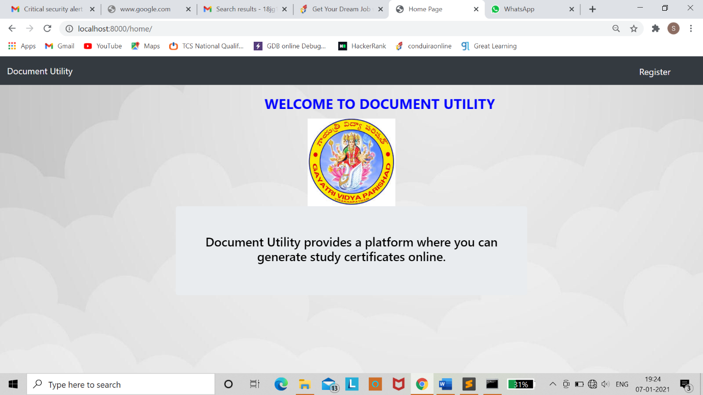

Eligibility Testing :

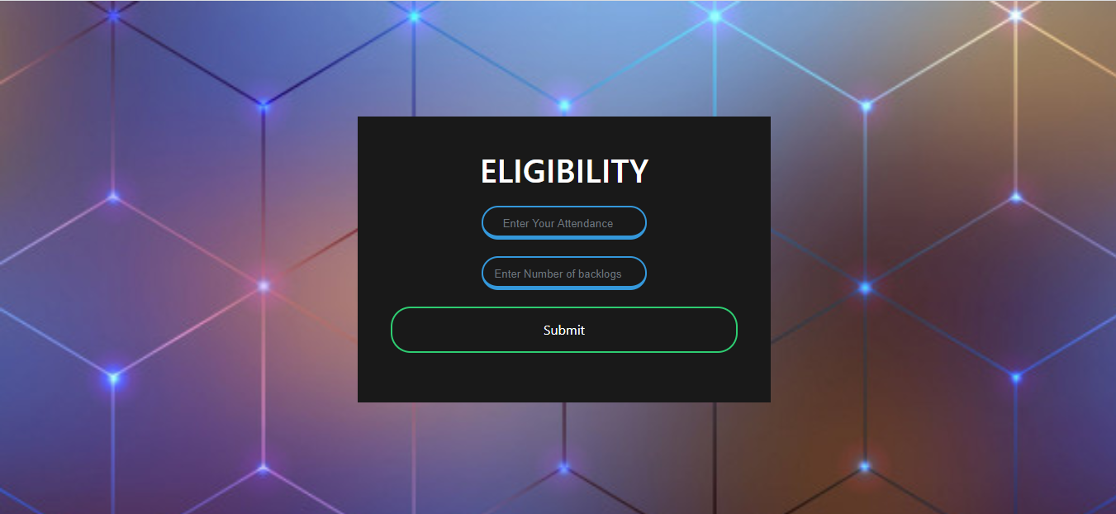

**Before clicking Submit :**

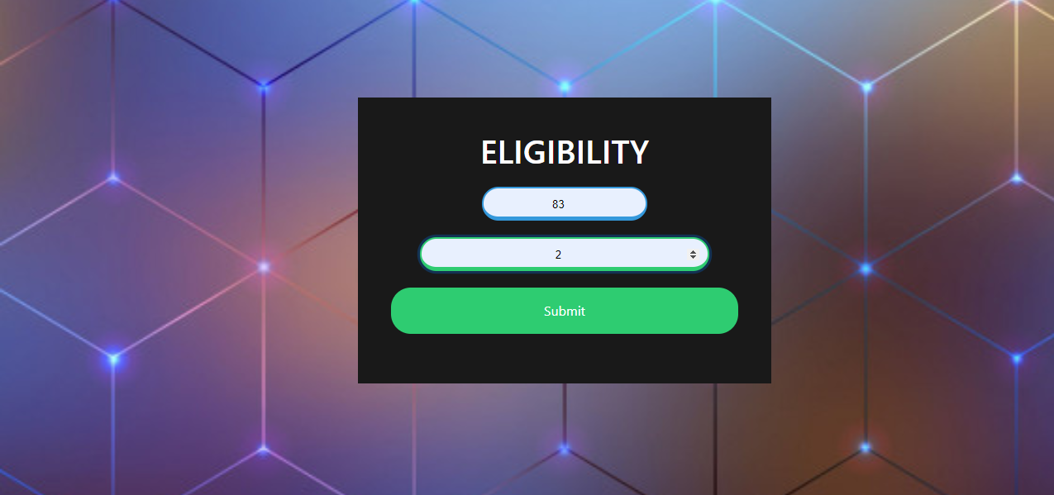

**If the data entered does not meet the requirements then the output is :**

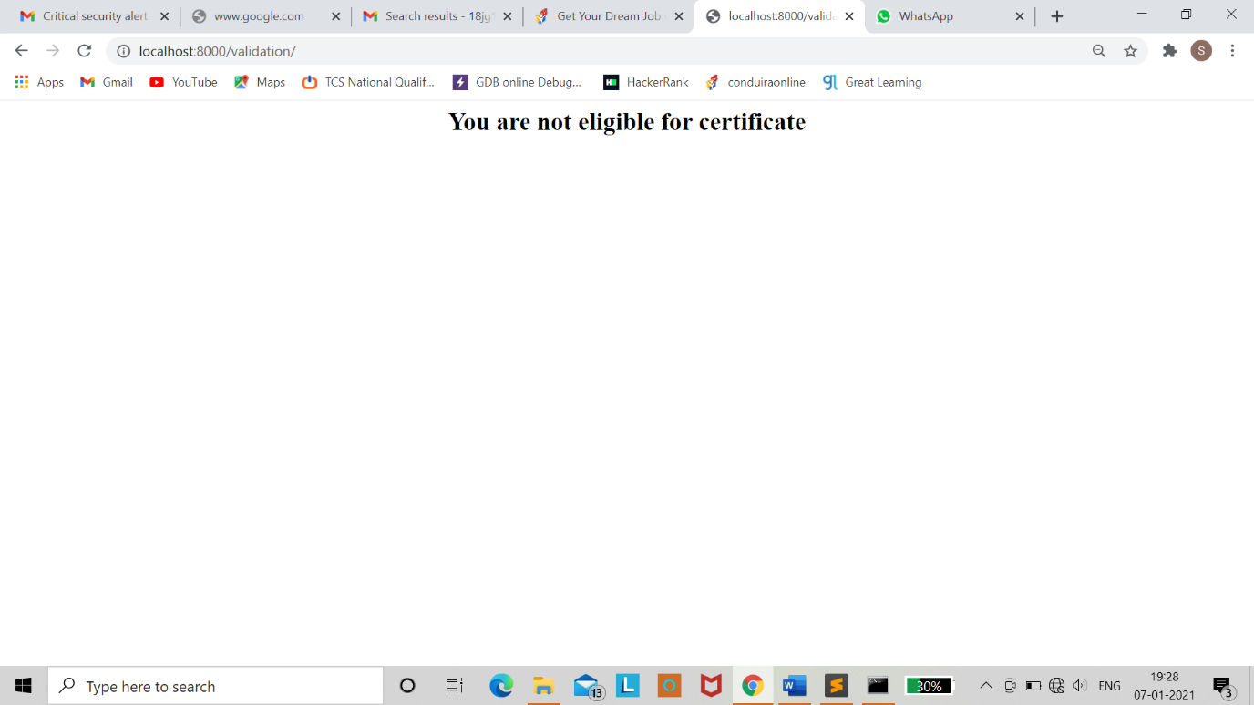

If the data entered is valid then page will be redirected to Registration page

**Registration Page :**

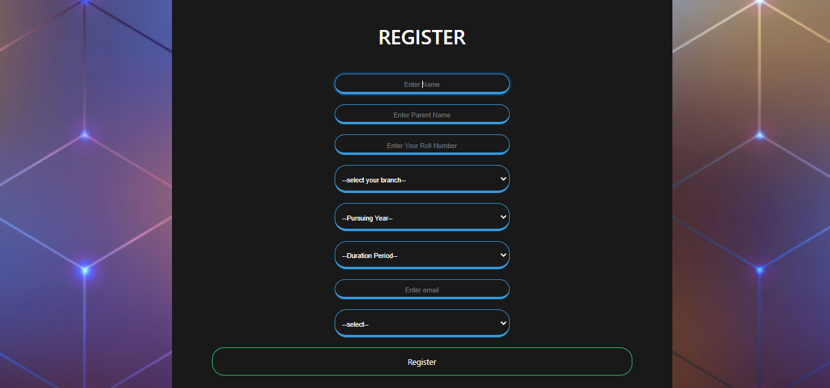

**Before Clicking Register Button :**

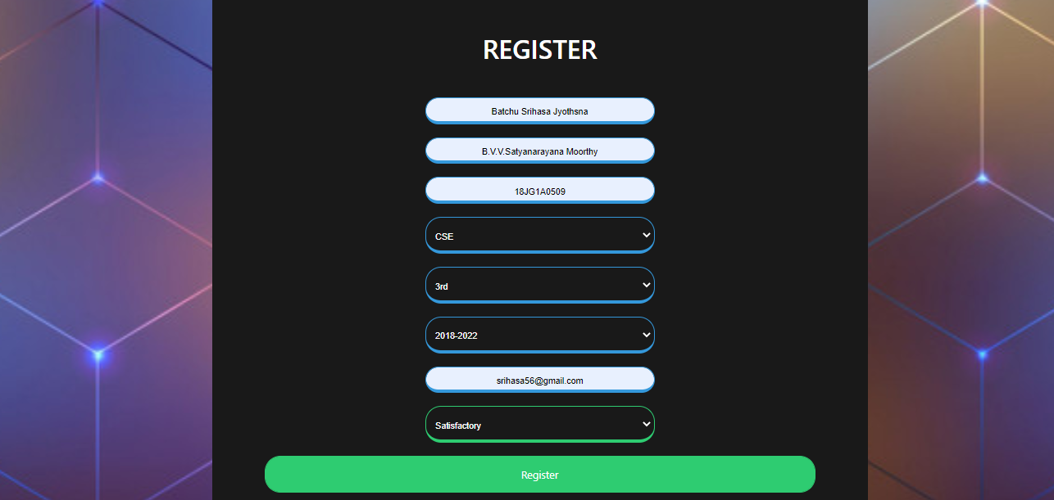

**After Clicking Register Button:**

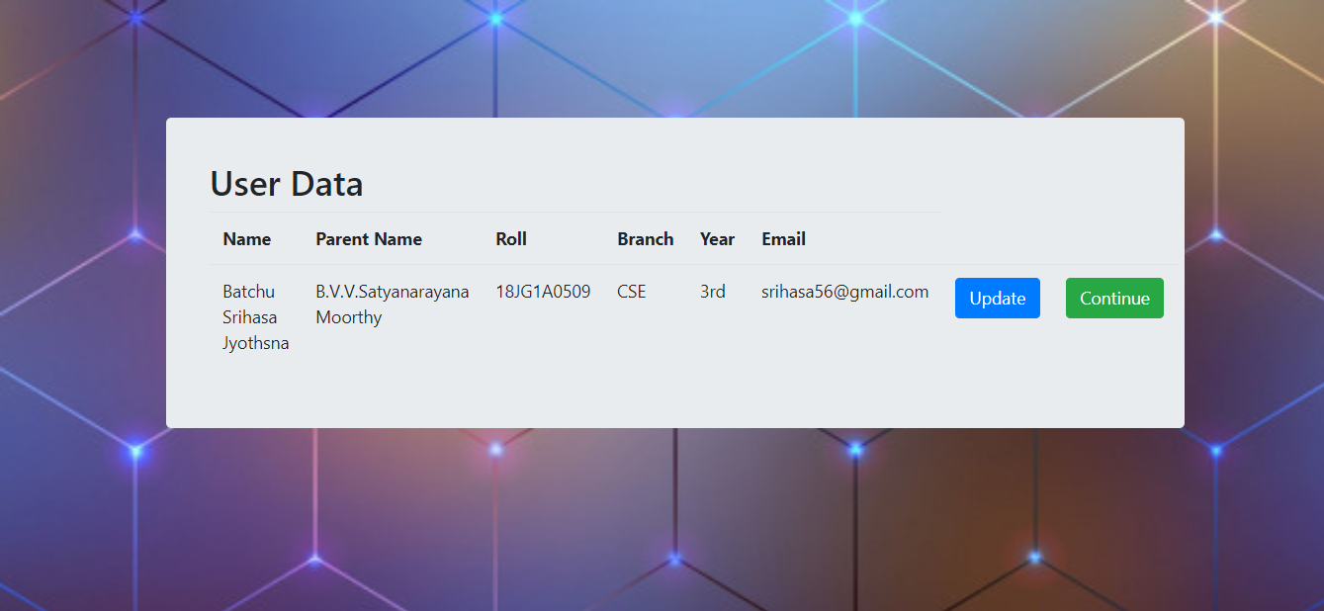

**If the student clicks on continue:**

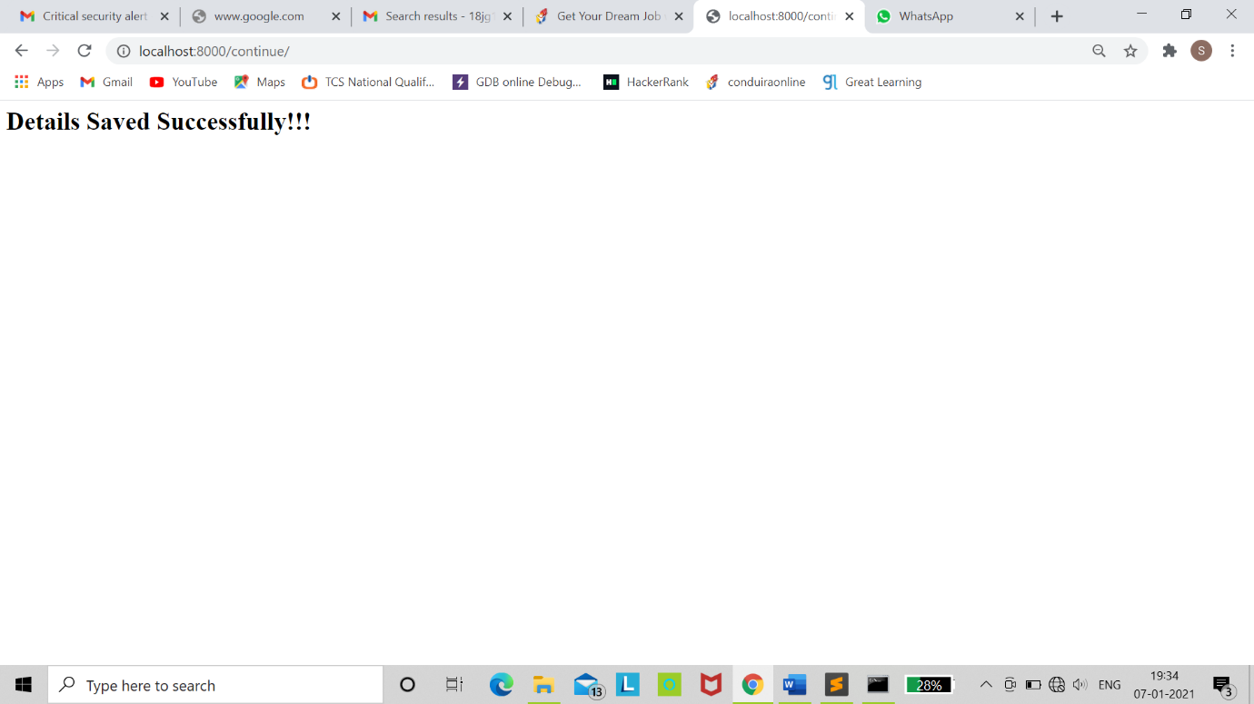

**If the student clicks on update :**

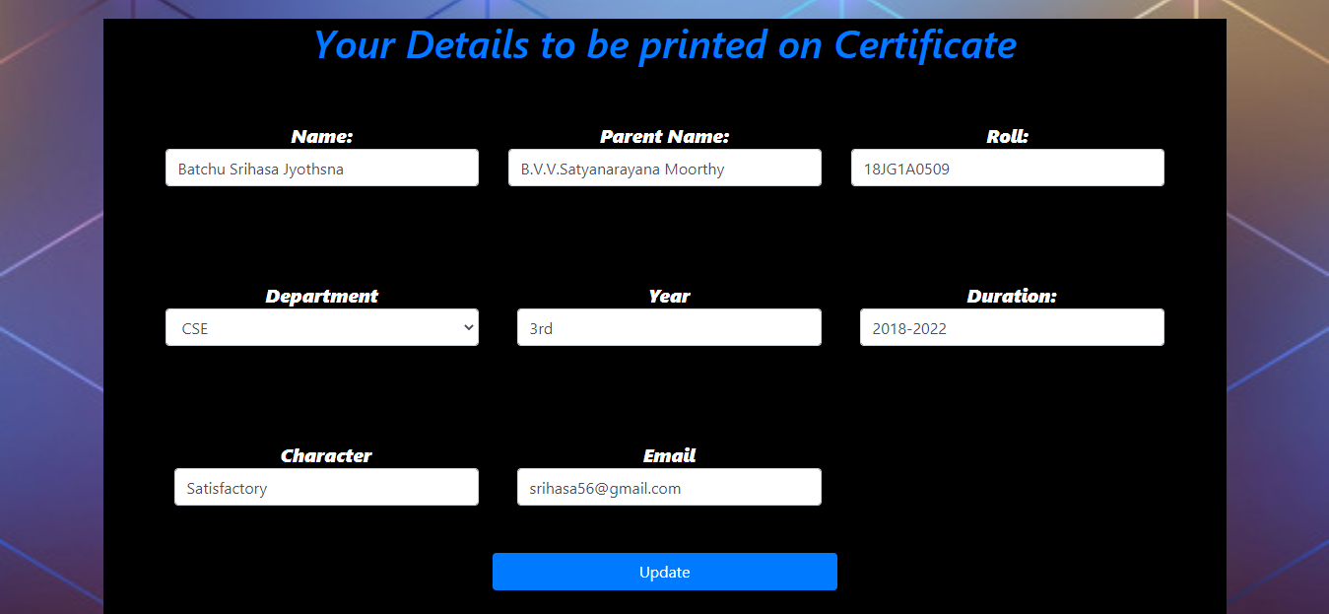

**After Updating the data and clicking on update button:**

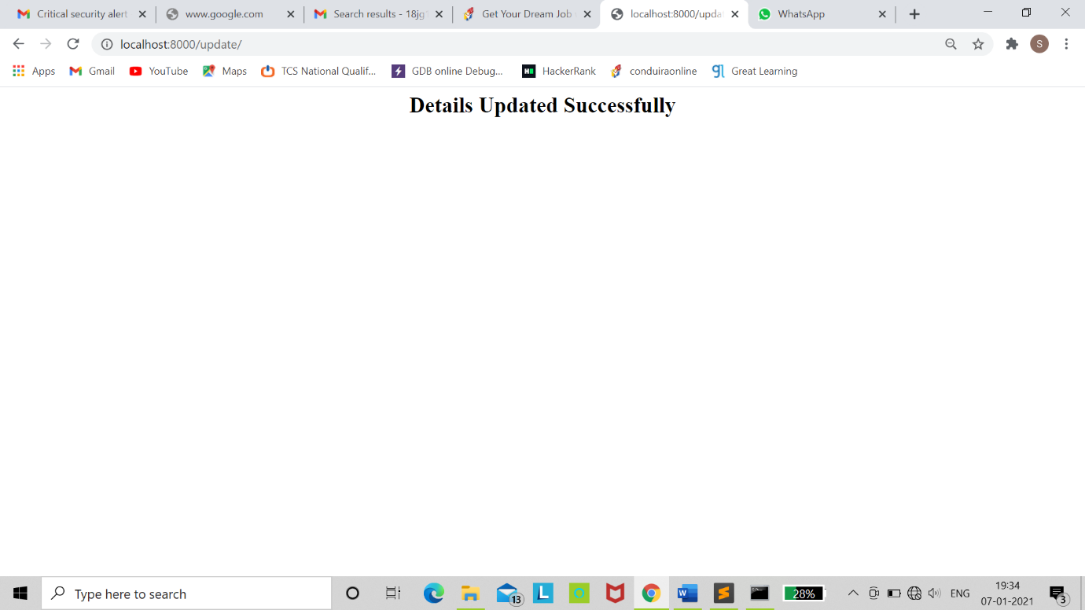

Above steps are followed by the student to apply for the Certificate. After that admin will retrieve the data from database and print the Certificate. Then certificates will be sent to mails of students in pdf format.

**Certificate:**



**Choosing File to send mail :**

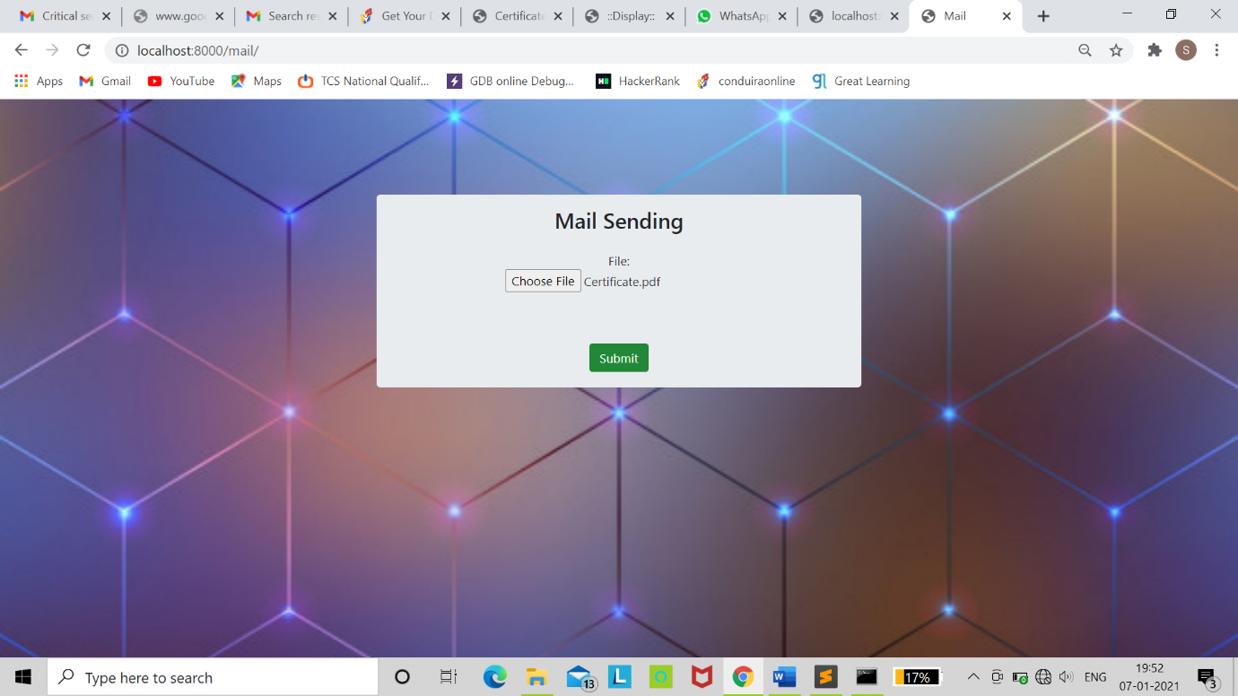

**After Clicking Submit :**

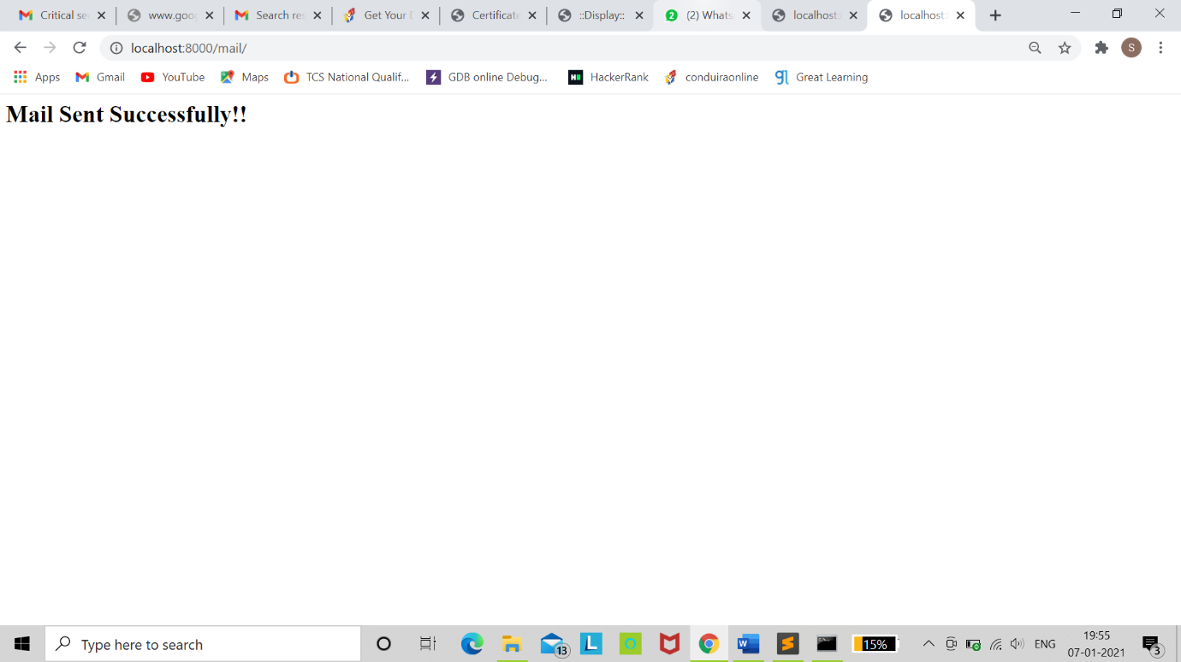

**CONCLUSION**

Document Utility Provides a way to generate an online study certificate which saves the time and resources. It helps the student to get the certificate in a speedy way when there is a urgent need.

As Everything is going online in the world and most of the certificates are generating in online there is a high scope of implementing the process of study certificate generation in online in coming days.